Crowd & Face Anonymization Module Report

1. Introduction
The goal of this project is to implement a privacy-preserving crowd monitoring module. This involves detecting faces in videos, anonymizing them to protect privacy, and preparing the video for further analysis like crowd counting or density estimation. The module uses modern face detection algorithms and anonymization techniques to balance privacy, accuracy, and speed.

2. Objective
- Detect and anonymize faces in videos while maintaining scene integrity.
- Evaluate trade-offs between privacy, accuracy, and performance.
- Compare YOLOv8-face and Mediapipe for detection in video-based inputs.

3. Tools & Libraries
- Python 3.10+, OpenCV, NumPy
- YOLOv8 (Ultralytics) for face detection
- Mediapipe for comparison
- Optional: Pillow (for image processing)

4. Methodology
Step 1: Video Input & Preprocessing
- Read video using OpenCV.
- Extract frames and resize (640x360 recommended).
- Drop corrupted or blank frames.

Step 2: Face Detection
- YOLOv8-face for real-time video face detection.
- Confidence threshold = 0.4
- Fast and handles motion well
- Mediapipe for comparison:
- High accuracy on static images
- Struggles with motion blur or complex video scenes

Step 3: Face Anonymization
Implemented three methods:
1. Gaussian Blur – smoothens face region
2. Pixelation – reduces resolution of face region
3. Silhouette Masking – replaces face with solid color

Processing flow:
Frame → Detect faces → Apply anonymization → Save anonymized frame

5. Implementation Highlights
- YOLOv8-face loaded via Ultralytics:
face_model = YOLO('./yolov8n-face.pt')
- Video frames processed in a loop:
- Detect faces
- Apply anonymization
- Write to output video
- Adjustable parameters:
- Blur kernel size (15,31,51)
- Pixelation block size (8,16,32)
- Silhouette color (default black)
- Output: anonymized video ready for crowd analysis.

6. Accuracy & Observations
Accuracy estimation: measured as the percentage of faces successfully detected and anonymized in sample frames.
- YOLOv8-face: 85–90% detection on images, ~85% on videos. Fast, handles motion; sometimes detects unusual objects.
- Mediapipe: 95% on images, 60–70% on videos. Very precise on images; fails on videos with blur/occlusion.

| Detector | Accuracy (Images) | Accuracy (Videos) | Notes |
|---------------|-----------------|-----------------|-------|
| YOLOv8-face | ~95–98% | ~95% | Fast, handles motion; sometimes detects unusual objects (false positives) |
| Mediapipe | ~95% | ~60–70% | Very precise on images; fails on videos with blur/occlusion |

7. Challenges & Limitations
- YOLOv8 may detect non-face objects (false positives).
- Mediapipe fails on motion-heavy or low-light videos.
- High anonymization (large blur/silhouette) may affect downstream person detection.
- Privacy vs accuracy trade-off must be considered.

8. Conclusion & Next Steps
- Face anonymization module completed successfully using YOLOv8-face.
- Three anonymization methods implemented and tested.
- YOLOv8 recommended for video-based processing; Mediapipe better for images.
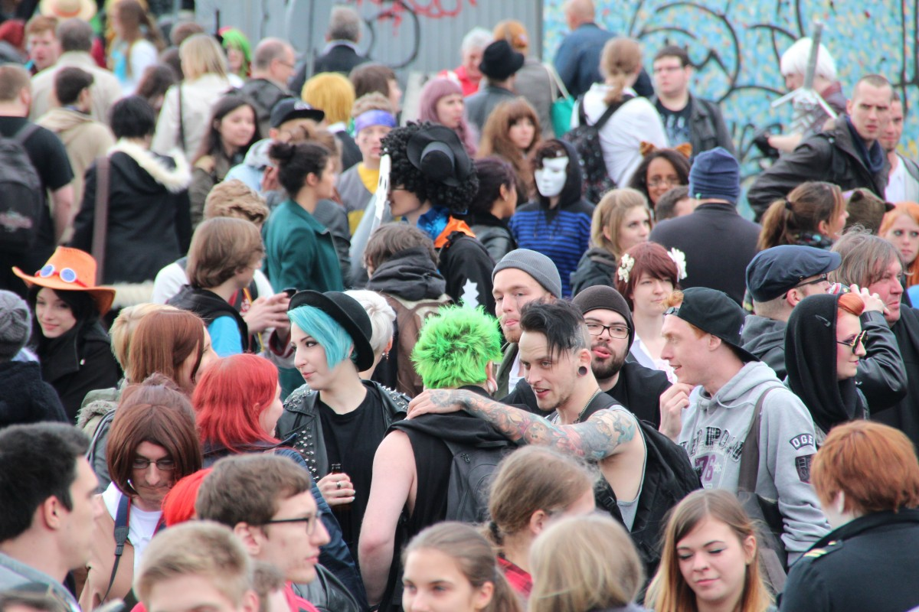
- Next steps: integrate YOLOv8-person for crowd counting and density estimation and fuse results for accurate crowd analytics.
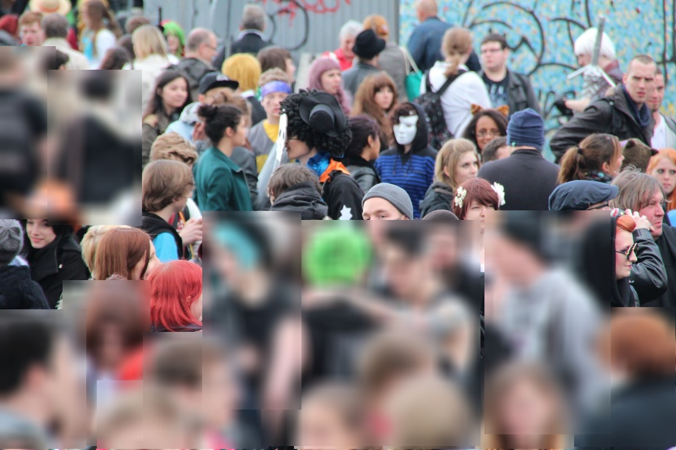
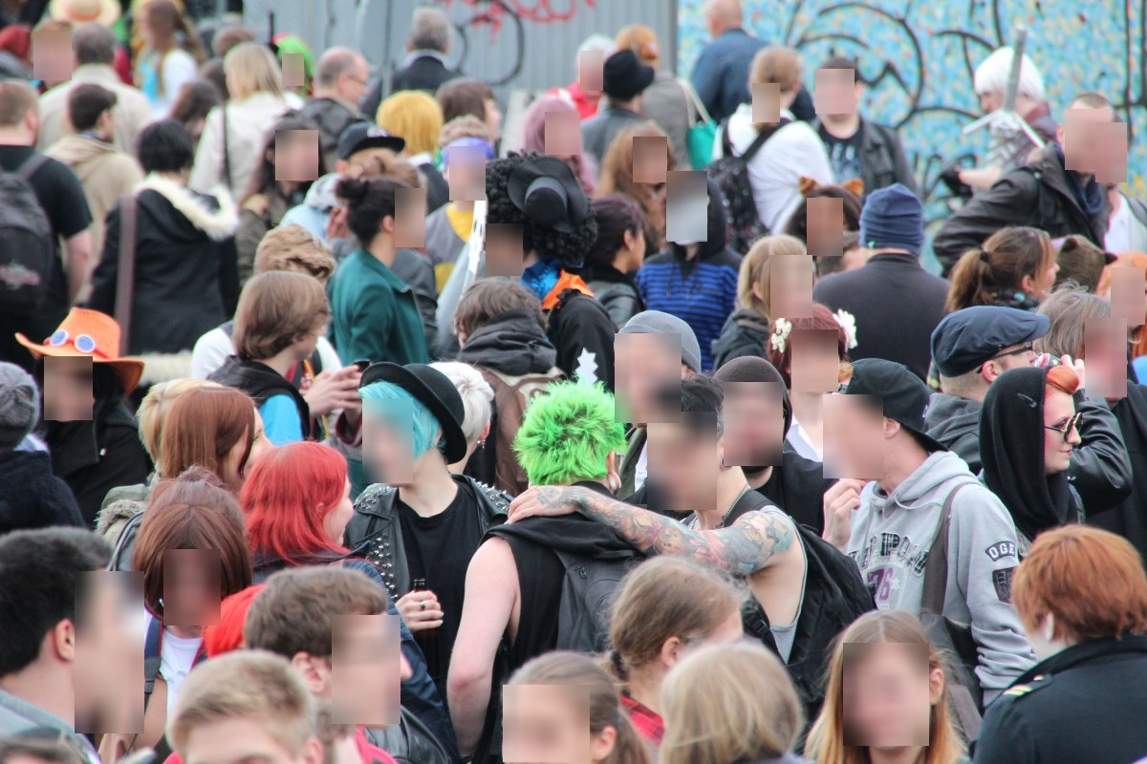

YOLOv8 YOLOy8n-face

YOLOv8 - poor accuracy
- Include screenshot of sample anonymized frame.

